Project Design Phase-II
Technology Stack (Architecture & Stack)

Date | 31 January 3035
Team ID | LTVIP2026TMIDS38821
Project Name | Exploratory Analysis of Rain Fall Data in India for Agriculture
Maximum Marks | 4 Marks

Technical Architecture:
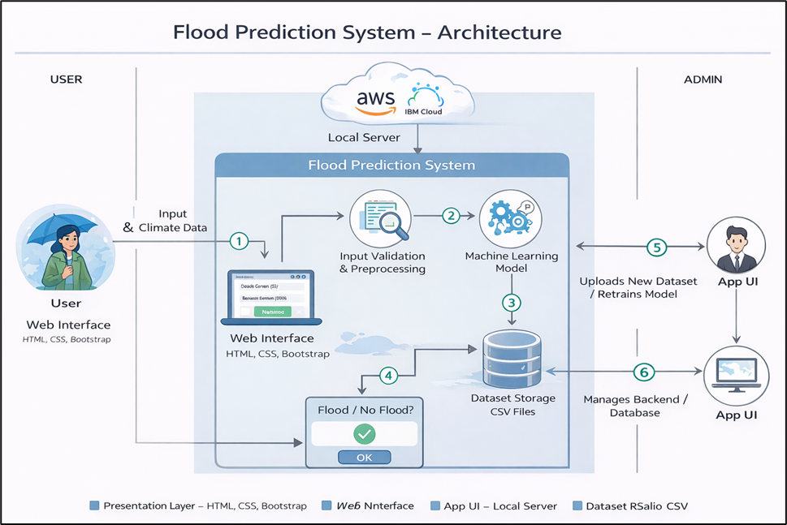

Table-1: Components & Technologies:
S.No | Component | Description | Technology
1. | User Interface | Web interface for entering rainfall parameters (State, Season, Month) and viewing prediction results | HTML, CSS, Bootstrap
2. | Application Logic-1 | Backend processing, routing, and request handling | Python, Flask
3. | Application Logic-2 | Data preprocessing (cleaning, scaling, feature encoding, validation) | Pandas, NumPy, Scikit-learn
4. | Application Logic-3 | Machine learning model prediction (Rainfall Category Prediction) | Random Forest, XGBoost
5. | Database | Structured historical rainfall dataset storage | CSV Files (Local Storage)
6. | Cloud Database | (Future Scope) Cloud storage for rainfall dataset | AWS S3 / IBM Cloud (Future Scope)
7. | File Storage | Storage of trained ML model (.pkl file) and scaler object | Local File System
8. | External API-1 | (Future) Real-time weather data integration | OpenWeather API (Future Scope)
9. | External API-2 | (Future) Agricultural advisory notification system | SMS / Email API (Future Scope)
10. | Machine Learning Model | Predict rainfall level (Low / Normal / High) based on input features | XGBoost Classifier / Random Forest
11. | Infrastructure (Server / Cloud) | Deployment environment | Local Server (Flask Development Server)

Table-2: Application Characteristics:

S.No | Characteristics | Description | Technology
1. | Open-Source Frameworks | Open-source libraries used for rainfall analysis and prediction | Flask, Scikit-learn, XGBoost, Pandas
2. | Security Implementations | Input validation and prevention of malicious data | Flask Input Validation, Form Validation
3. | Scalable Architecture | Modular architecture supporting model retraining & API integration | 3-Tier Architecture (UI, Logic, Data)
4. | Availability | Web-based access through browser without installation | Flask Web Server
5. | Performance | Rainfall prediction response generated within seconds | Pre-trained ML model, Optimized Data Pipeline
6. | Maintainability | Structured and modular codebase for easy updates | Python Modular Structure

References:
C4 Model for Architecture Diagrams – https://c4model.com/
IBM Cloud Architecture Patterns – https://developer.ibm.com/patterns/
IBM Cloud Architecture Center – https://www.ibm.com/cloud/architecture
AWS Architecture Center – https://aws.amazon.com/architecture
How to Draw Useful Architecture Diagrams – https://medium.com

